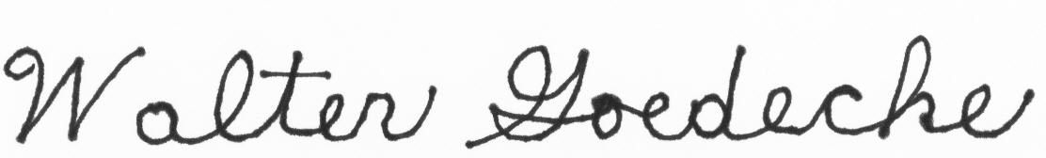
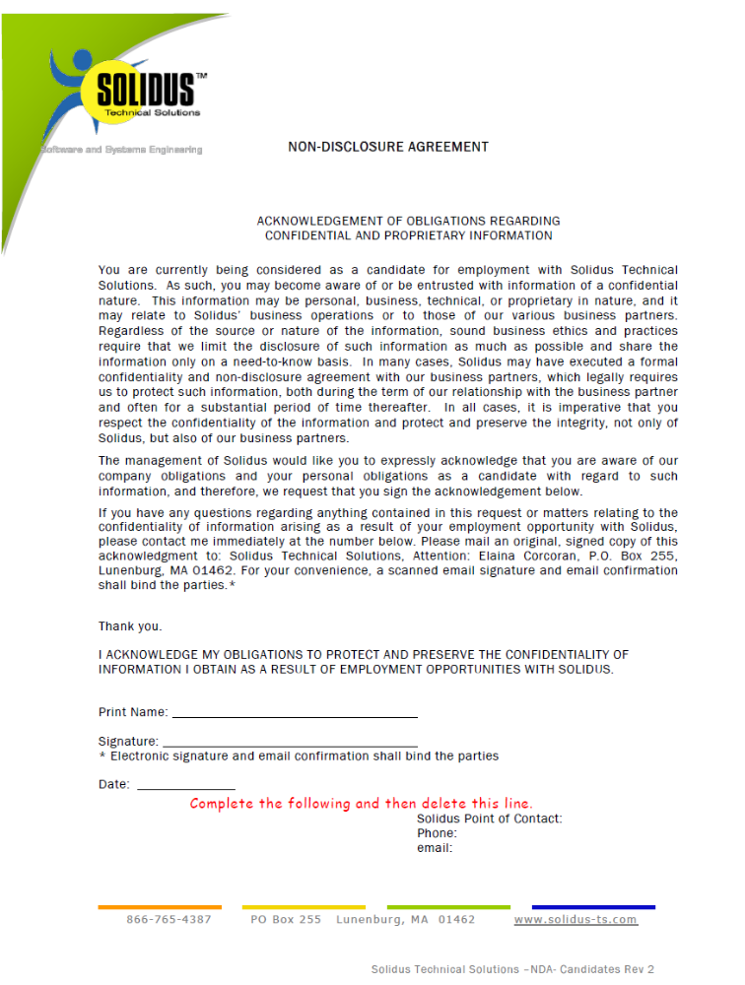
Walter Goedecke
July 6, 2015

